Lab 4 : Supernetting and Subnetting

Objectives :

- To understand the concepts of subnetting and supernetting, and to implement them practically using Cisco Packet Tracer.
- Executing practical implementations of these networking techniques within a simulated Cisco Packet Tracer environment.

Software Requirements :

- Cisco Packet Tracer
- Operating System: Windows
- PDF/MS Word (for documentation and report writing)

Theory :

- Subnetting :

Subnetting involves partitioning a extensive IP network into multiple smaller, logically separated segments known as subnets. This is achieved by "borrowing" specific bits from the host portion of an IP address to expand the network portion, thereby creating several unique network addresses from a single base block.

Base network : 192.168.1.0/24

Required number of subnets : Divide into 4 distinct segments.

No. of IP addresses per subnet : 64

Subnet | Network | Broadcast | First usable IP | Last usable IP
 | Address | Address
00 | 192.168.1.0 | 192.168.1.63 | 192.168.1.1 | 192.168.1.62
01 | 192.168.1.64 | 192.168.1.127 | 192.168.1.65 | 192.168.1.126
10 | 192.168.1.128 | 192.168.1.191 | 192.168.1.129 | 192.168.1.190
11 | 192.168.1.192 | 192.168.1.255 | 192.168.1.193 | 192.168.1.254

Network Topology :

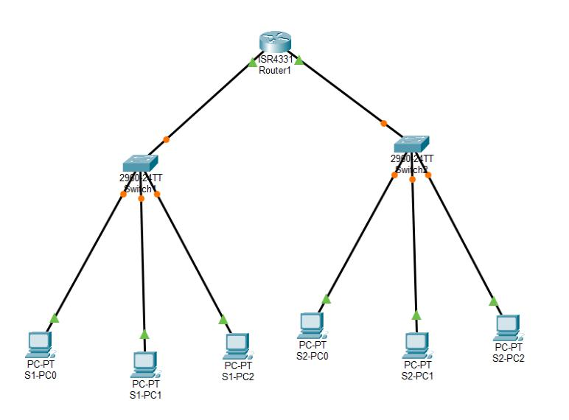

Configuration :

For first switch :

Device | IPV4 | Subnet Mask | Default gateway
PC-PT S1-PC0 | 192.168.1.2 | 255.255.255.192 | 192.168.1.1
PC-PT S1-PC1 | 192.168.1.3 | 255.255.255.192 | 192.168.1.1
PC-PT S1-PC2 | 192.168.1.4 | 255.255.255.192 | 192.168.1.1
For second switch :
Device | IPV4 | Subnet Mask | Default gateway
PC-PT S1-PC0 | 192.168.1.66 | 255.255.255.192 | 192.168.1.65
PC-PT S1-PC1 | 192.168.1.67 | 255.255.255.192 | 192.168.1.65
PC-PT S1-PC2 | 192.168.1.68 | 255.255.255.192 | 192.168.1.65

- Supernetting :

Supernetting or CIDR (Classless Inter-Domain Routing) aggregation, is the inverse process where several smaller, contiguous networks are combined into one larger network block. By shortening the subnet mask, the number of available hosts per network increases while the number of individual entries in a routing table decreases.

Key conditions :
- Networks being combined must be numerically contiguous

- T he total number of networks involved must be a power of two.

Network Topology :

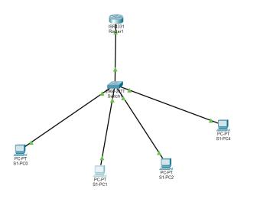

Configuration :

Device | IPV4 | Subnet Mask | Default Gateway
PC-PT S1-PC0 | 192.168.1.10 | 255.255.252.0 | 192.168.1.1
PC-PT S1-PC1 | 192.168.2.10 | 255.255.252.0 | 192.168.1.1
PC-PT S1-PC2 | 192.168.3.10 | 255.255.252.0 | 192.168.1.1
PC-PT S1-PC4 | 192.168.4.10 | 255.255.252.0 | 192.168.1.1

Result :

The practical application of both subnetting and supernetting was effectively carried out within the Cisco Packet Tracer environment. By applying a /26 subnet mask, the initial 192.168.1.0/24 network was partitioned into four uniform sub-networks. This configuration allocated 62 usable IP addresses to each segment and ensured seamless data exchange within those segments via accurate gateway setup.
For supernetting, several adjacent Class C network blocks were consolidated into a unified structure using a /22 mask. This aggregation facilitated efficient inter-network communication. The integrity of the IP assignments, subnet boundaries, and gateway configurations was confirmed through successful ping connectivity tests.

Discussion and Conclusion :

The lab successfully demonstrated the practical application of both subnetting and supernetting. Through Cisco Packet Tracer, we verified that proper IP planning is essential; even minor configuration errors can disrupt communication. Subnetting proved effective for creating manageable, secure sub-units, while supernetting proved vital for scaling networks and optimizing routing tables. Connectivity was confirmed via successful ping tests across all configured devices.

